**Experiment name:** **Some important command in Linux terminal.**

**Aim and goals:**

**1.** Learning how to use command in Linux Terminal.

**2.** To improve as a operator out of the graphical interface.

**3.** To be more professional in Linux.

**Some important and basic command in Linux terminal:**

**1.To show all thing in a particular place Linux use “ls” command.**

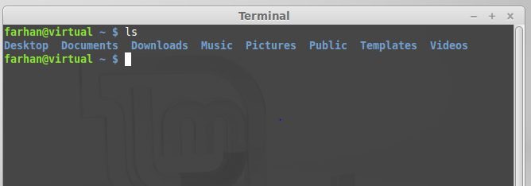

**2. To change the directory Linux use “cd dir_name” command.**

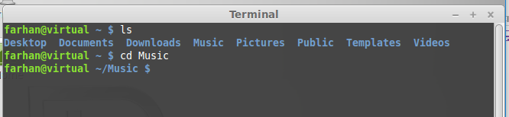

**3. To make a directory Linux use “mkdir directory_names” command.**

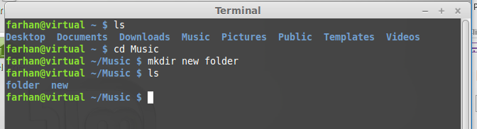

**4. To delete a directory Linux use “rm -r directory_name” command.**

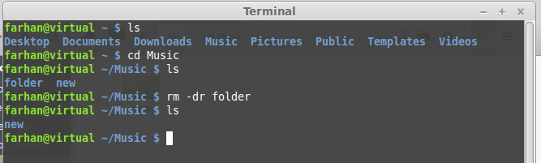

**5. To show the path of current place Linux use “pwd” command.**

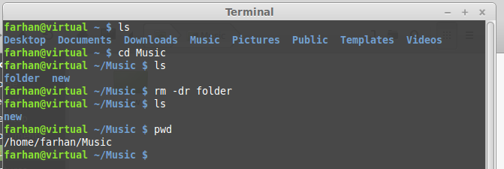

**6. To create a file Linux use ”touch file_name” command.**

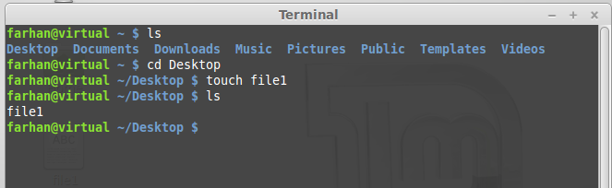

**7. To read from a file Linux use “head file_name” command.**

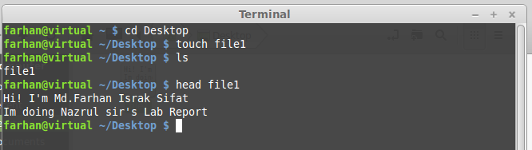

**Conclusion:**

**Using command in linux is too much important. We can do almost all kind of work using command in command terminal. In this lab report I tried some of the basic Linux command to do some basic task. This tasks are, how to see all thing in the directory, create directory, delete directory, create file, write in the file,read from file, delete file, show the specific directory path. And doing this thing I feel that I have learnt the basic terms.**